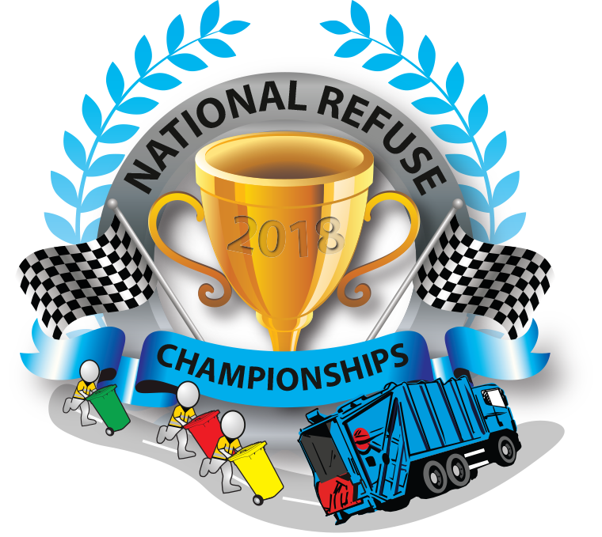

With pics: The National Refuse Championships 2017

PRESS RELEASE

Bin Lorry Racing Returns To Weston-super-Mare

The National Refuse Championships is returning to Weston-super-Mare on Friday 15 & Saturday 16 June 2018, and promises to be even bigger and better than last year’s event.

The first ever National Refuse Championships took place in June 2017 at Weston-super-Mare where over 100 refuse vehicle drivers and loaders from across the UK gathered to compete in a series of races. Over £12000 was raised for The Alzheimer’s Society and Aylesbury Vale District Council won the title of National Refuse Champions. Such was the success of the day that the organisers, Refuse Vehicle Solutions Ltd (RVS), have decided to make it an annual event.

Spencer Law, Managing Director of RVS and Founder of the NRC: “I’ve wanted to create the National Refuse Championships for years, but it wouldn’t have been possible without the amazing support and generosity of friends, family, staff and the waste management industry. We are well underway with preparations for this year’s event, which is going to be bigger and better, and we hope to raise even more money for The Alzheimer’s Society.”

Without doubt the most fun event in the waste management industry calendar, the National Refuse Championships is a great opportunity to celebrate our refuse collection crews and the valuable job they do. Members of the pubic are welcome to spectate, free of charge, and there is something for the whole family, no matter how young or old.

This year’s event will be much bigger with double the number of teams. Over 29 crews, from private waste companies and local authorities across the UK, have already signed up. A few places remain but they are going fast!

Teams so far include Biffa, Amey, Grundon, Cawleys, FCS Cleaning, Swindon County Council, Gullivers Truck Hire, Kier, Devon Contract Waste, Oxford City Council, Aberdeen City Council, Weir Waste, Vehicle Weighing Solutions Ltd, Simply Waste, Cartskips, ASL, Cawleys and Pirtek.

Last year’s winners, Aylesbury Vale District Council, are entering two teams, one of which is all-female, in a bid to defend their title. As last year each member of the winning team will receive vouchers towards a Center Parcs holiday, second place team members will each receive £250 worth of Buy-A-Gift Vouchers, and each third place team member will receive £200 worth of Buy-A-Gift Vouchers.

David Clark, Transport Manager, Aylesbury Vale District Council (AVDC): “Since winning the event last year there has been so much positivity across the crews and council departments, which is fantastic. It has been great for team-building. Our female crew members are keen to show that they can beat the men.”

This year the event includes an exhibition day on Friday 15th June with seminars, presentations and product demonstrations, as well as activities for schools and children.

The races take place from 10am-5.30pm on Saturday 16th June, after which there will be a party held for participants in a Marquee on the Beach Lawns with live music and a Fish ‘n’ Chip supper. The headline sponsor is specialist contract hire, asset finance and fleet management services provider, Indelease.

Refuse vehicle manufacturer, Dennis Eagle, is sponsoring a fundraising drinks reception with live music during the evening on Friday 15th June at Weston-super-Mare Winter Gardens, which has undergone £15m renovation and refurbishment. Imperial Commercials is sponsoring the Start and Finish Lines.

For more information about this year’s event visit www.nationalrefusechampionships.co.uk. To find out how to enter a team, or for details of sponsorship and exhibition opportunities, contact the Event Organiser Tracy Standing on Tel: 07772 500 736 or email tracy.standing@rvsl.co.uk.

ENDS. January 2018

Media Contact: Clare Summers tel: 07771 524 596 email: clare@summersmarketing.com

