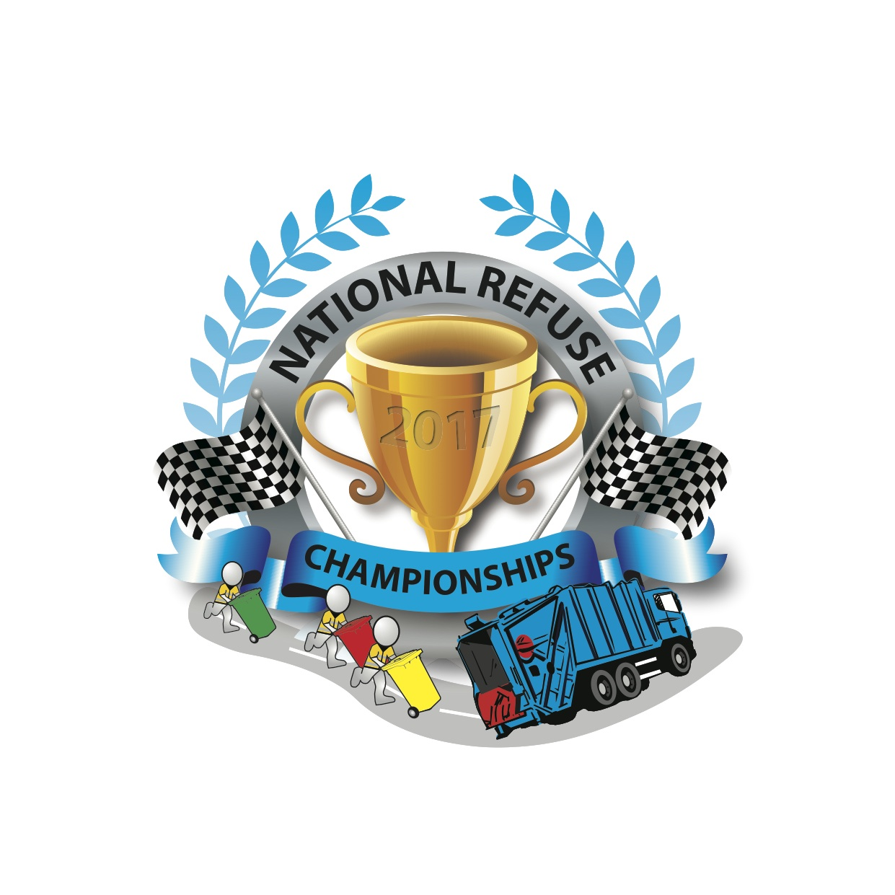

PRESS RELEASE

Bin Lorry Races At Weston-super-Mare!
Saturday 10 June 2017

In June this year visitors to Weston-super-Mare seafront can witness a very unusual event as over 160 refuse vehicle drivers and loaders from across the UK congregate to compete in a race of skills, stamina and strength to win the coveted National Refuse Champions Trophy 2017.

The National Refuse Championships take place at 10am-4pm on Saturday 10 June, and involve 32 teams of 5 people working in pairs (with one driver) to load large wheelie bins with stones and push them 50m to empty into awaiting refuse vehicles. This gruelling process is repeated numerous times as the trucks move forwards in 50m stages until they reach the finish line. Members of the public can watch the games from the promenade and seafront.

Formerly known as the World Refuse Championships, this exciting charity event last took place in 1995 in Worthing, and is being revived by a group of refuse vehicle enthusiasts to raise money for Alzheimer’s Society.

The idea is the brainchild of Spencer Law who has spent over 20 years in the waste management sector and runs his own company, Refuse Vehicle Solutions Ltd (RVS) based in South Gloucestershire:

Spencer said: “I remember the original event, which was such great fun and a superb way to raise money for a good cause. It’s important to recognise the hard work of these people who collect our rubbish and an opportunity for them to show how good they are!”

Laura Hewitt, Community Fundraiser at Alzheimer's Society said: "It's fantastic that RVS have chosen to unite with us against dementia and we're delighted to be chosen as their charity partner for the National Refuse Championships.

“Until the day we find a cure, Alzheimer's Society will be here for anyone affected by dementia - wherever they are, whatever they're going through."

UK-based refuse vehicle manufacturer, Dennis Eagle is the lead sponsor for the event.
The winning team will receive a prize of weekend away at Center Parcs for them and their families.

For more information about the event visit www.nationalrefusechampionships.co.uk. To enter a team or make a donation contact tracy.standing@rvsl.co.uk or contact Tracy on Tel: 07772 500 736.

ENDS.
Media Contact: Clare Summers tel: 07771 524 596 email: clare@summersmarketing.com

